Adam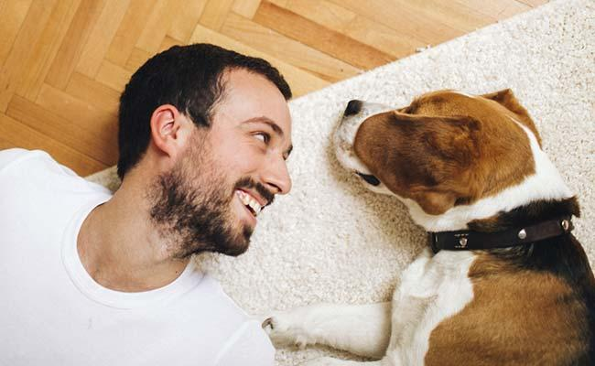

About

Adam is a 29 year old construction worker who has a dog named Buddy. He works many hours but loves to take his dog to the dog park on weekends. In his spare time Adam designs websites and likes to skateboard

Ultimate Goals

To find a playmate for his dog Buddy

Meet more dog owners with similar interests.

Interests

Programming

Traveling

Craft Beer

Sports

Quote

“Weekends are for my dog”